LAB EXPERIMENTS
N.Yugesh(192424329)
Experiment 1 – Set 1: Monthly Sales Data
- Create a line chart to visualize the monthly sales. Label the axes and title the chart appropriately.
Code:
Month <- c("January","February","March","April","May") Sales <- c(15000,18000,22000,20000,23000)
plot( Sales, type="o", col="blue", xaxt="n",
xlab="Month", ylab="Sales ($)",
main="Monthly Sales Data"
)
axis(1,at=1:5,labels=Month)
output:
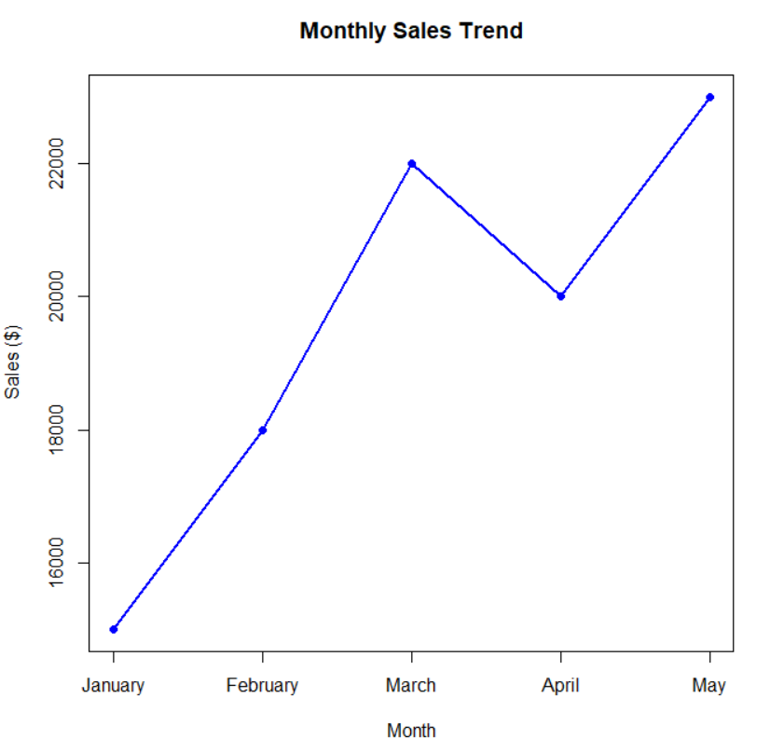

- Generate a bar chart to display the top-selling products for the year. Label the chart elements.
Code:
Product <- c("Product A","Product B","Product C","Product D","Product E") Sales <- c(2500,4200,3100,5000,3800)
barplot( Sales,
names.arg=Product, col="orange", xlab="Products", ylab="Sales",
main="Top Selling Products"
)
Output:
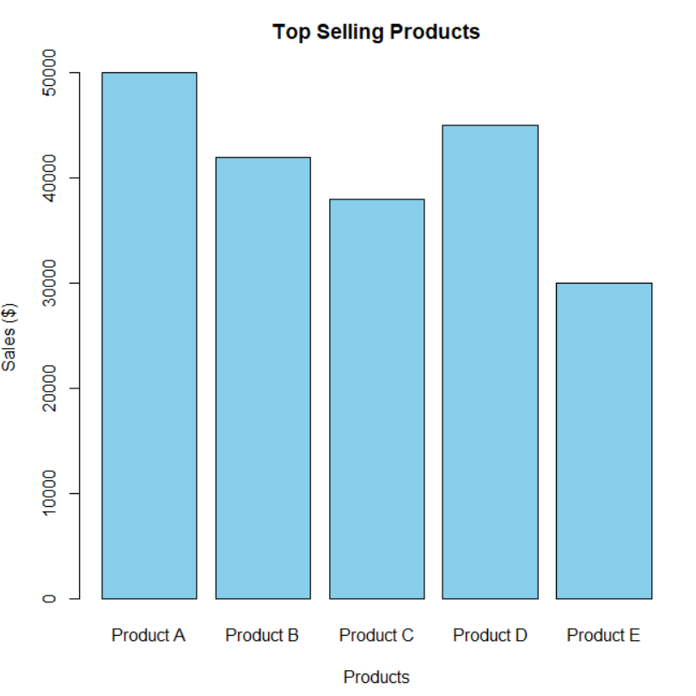

- Develop a scatter plot to explore the relationship between advertising budget and monthly sales. Explain the insights drawn from the scatter plot.
Code:
Advertising <- c(2000,2500,3000,2800,3500) Sales <- c(15000,18000,22000,20000,23000)
plot( Advertising, Sales, pch=19, col="red",
xlab="Advertising Budget ($)", ylab="Monthly Sales ($)", main="Advertising Budget vs Monthly Sales"
)
abline(lm(Sales~Advertising),col="blue",lwd=2)

output:
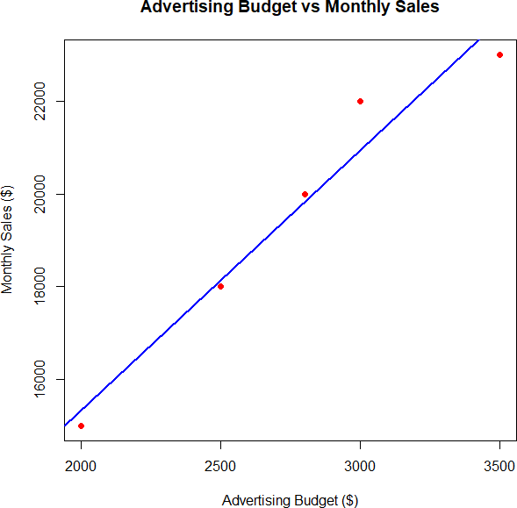

SET 2 – Customer Feedback Analysis
- Create a histogram to represent the distribution of customer ages. Label the axes and title the chart.
Code:
Age <- c(25,30,35,28,40)

hist( Age,
col="skyblue",
main="Distribution of Customer Ages", xlab="Age",
ylab="Frequency"
)

Output:
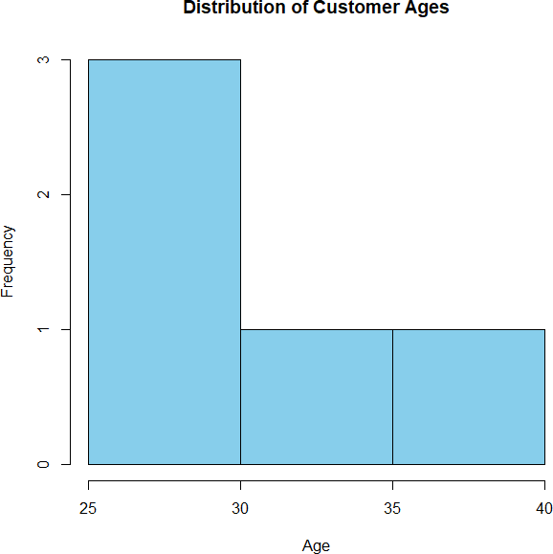

- Generate a pie chart to display the overall distribution of customer satisfaction scores. Include labels.
Code:
Satisfaction <- c(4,5,3,4,5)

table_score <- table(Satisfaction) pie(
table_score,
main="Customer Satisfaction Scores", col=c("red","green","yellow")
)

Output:
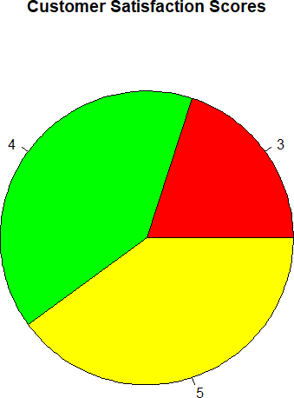

- Build a stacked bar chart to visualize the distribution of customer satisfaction scores by age group.
Code:
AgeGroup <- c("20-30","20-30","31-40","20-30","31-40")
Satisfaction <- c(4,5,3,4,5)
data <- table(AgeGroup,Satisfaction) barplot(
data, col=c("orange","lightgreen","pink"), main="Satisfaction by Age Group", xlab="Age Group",
ylab="Count", legend=TRUE
)

Output:
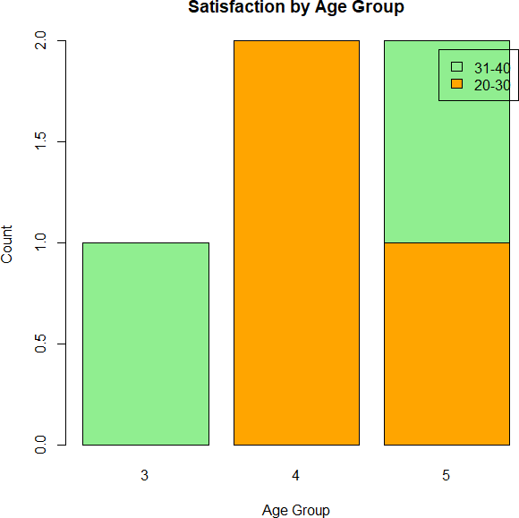

3. Develop a word cloud from open-ended customer feedback to identify prevalent customer Code:
install.packages("wordcloud") library(wordcloud)
feedback <- c( "Good Service", "Excellent Support", "Fast Delivery", "Good Quality", "Excellent Product"
)
wordcloud( feedback, colors=rainbow(5)
)

Output:

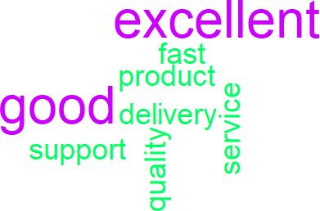

Set 3: Employee Performance Evaluation
- Create a line chart to visualize the performance trend of employees over time. Include a legend and labels.
Code:
Employee_ID <- c(1,2,3,4,5) Performance_Score <- c(85,92,78,90,76)

plot(
Employee_ID, Performance_Score, type="o", col="blue", pch=16,
xlab="Employee ID", ylab="Performance Score", main="Employee Performance Trend"
)

Output:

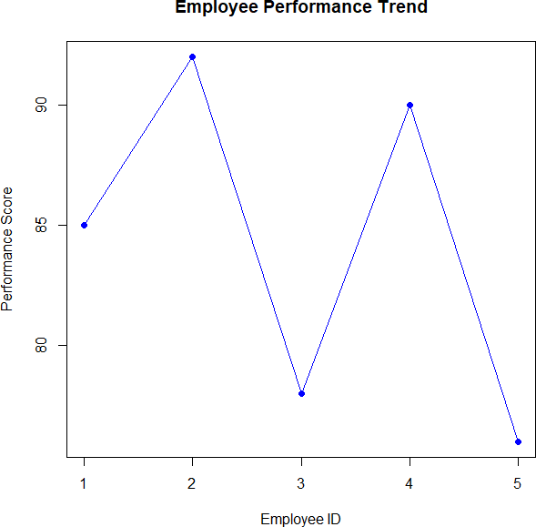

- Generate a bar chart showing the distribution of employees across different departments. Label the chart elements.
Code:
Department <- c("Sales","HR","Marketing","Sales","HR") dept_count <- table(Department)
barplot( dept_count, col="orange",
main="Employees by Department", xlab="Department", ylab="Number of Employees"
)

Code:

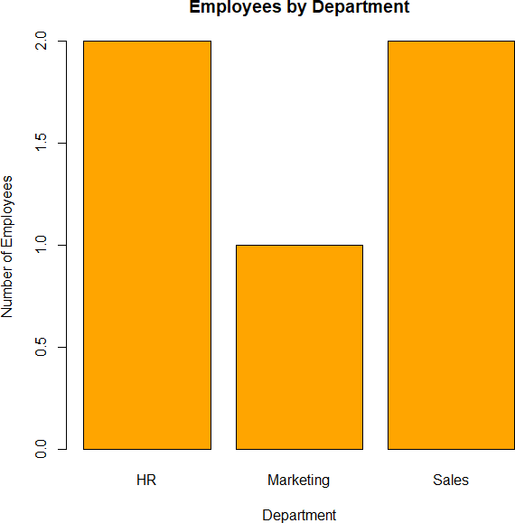

- Build a scatter plot to analyze the correlation between years of service and performance scores.
Explain any insights.
Code:
Years_of_Service <- c(5,3,7,4,2) Performance_Score <- c(85,92,78,90,76)

plot(
Years_of_Service, Performance_Score, pch=19, col="red",
xlab="Years of Service", ylab="Performance Score",
main="Years of Service vs Performance Score"
)

abline(lm(Performance_Score ~ Years_of_Service), col="blue",
lwd=2)

output:

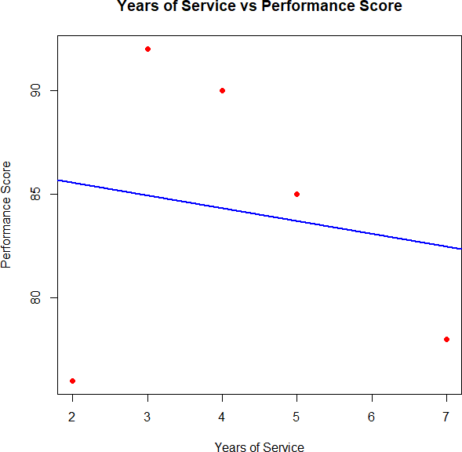

Set 4: Product Inventory Management
- Create a bar chart to visualize the quantity of each product in the inventory. Label the axes and title the chart.
Code:
Product <- c("Product A","Product B","Product C","Product D","Product E") Quantity <- c(250,175,300,200,220)

barplot( Quantity,
names.arg = Product, col = "skyblue", xlab = "Products",
ylab = "Quantity Available", main = "Product Inventory"
)

Output:

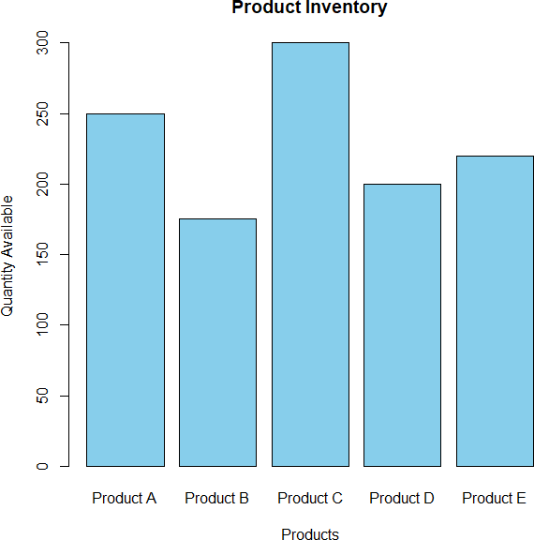

- Generate a stacked bar chart to show the quantity of each product within different product categories.
Code:
Category <- matrix( c(120,130,
80,95,
150,150,
90,110,
100,120),
nrow=2)

colnames(Category) <- c("Product A","Product B","Product C","Product D","Product E")
rownames(Category) <- c("Category 1","Category 2") barplot(
Category,
col=c("orange","lightgreen"),
main="Stacked Bar Chart of Product Categories", xlab="Products",
ylab="Quantity", legend=rownames(Category)
)

Output:

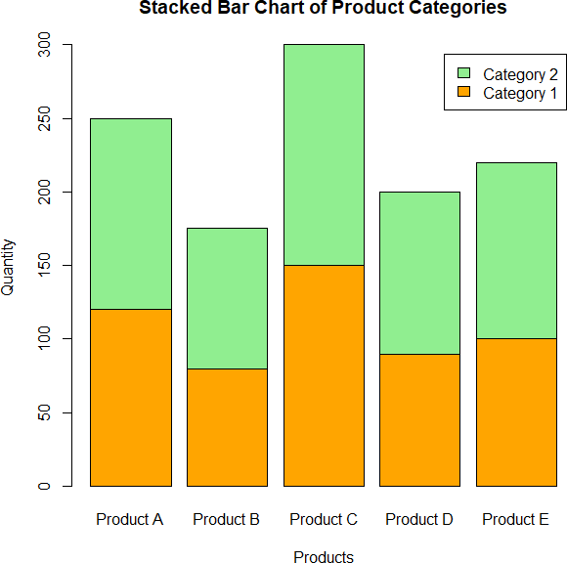

- Build a scatter plot to explore the relationship between product price and quantity available.
Explain the findings.
Code:
Price <- c(20,15,18,22,25) Quantity <- c(250,175,300,200,220)

plot( Price, Quantity, pch=19, col="red",
xlab="Product Price ($)", ylab="Quantity Available", main="Price vs Quantity Available"
)

abline(lm(Quantity~Price),col="blue",lwd=2)

output:

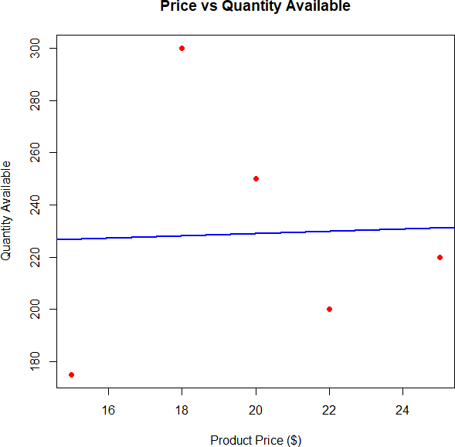

Set 5: Website Analytics
- Create a line chart to visualize the trend in daily page views over time. Label the axes and title the chart.
Code:
Date <- as.Date(c("2023-01-01",
"2023-01-02",
"2023-01-03",
"2023-01-04",
"2023-01-05")) Page_Views <- c(1500,1600,1400,1650,1800)
plot( Date, Page_Views, type="o", col="blue", pch=16,
xlab="Date", ylab="Page Views",
main="Daily Website Page Views"
)

Output:

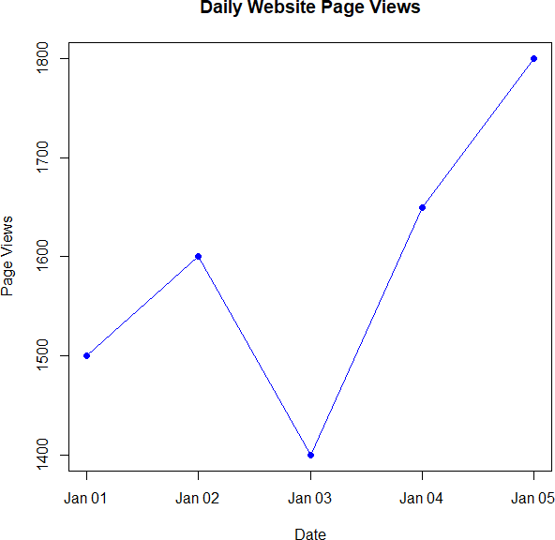

Generate a bar chart showing the top N days with the highest click-through rates. Label the chart elements.
Code:
Date <- c("Jan 1","Jan 2","Jan 3","Jan 4","Jan 5")

CTR <- c(2.3,2.7,2.0,2.4,2.6)

barplot( CTR,
names.arg=Date, col="orange", xlab="Date",
ylab="Click-through Rate (%)", main="Daily Click-through Rate"
)

Output:

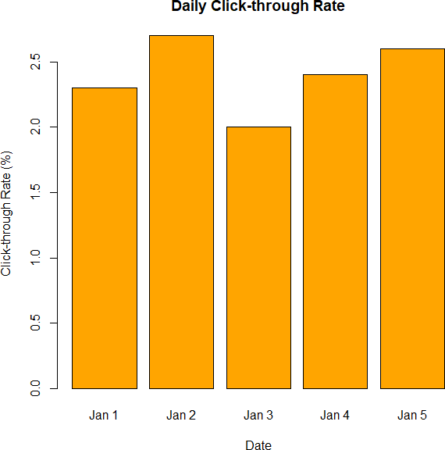

Develop a stacked area chart to display the distribution of user interactions (likes, shares, comments) on a website.
Code:
Days <- 1:5

Likes <- c(100,120,140,160,180) Shares <- c(50,60,70,80,90) Comments <- c(20,25,30,35,40)
interaction_data <- rbind(Likes,Shares,Comments) barplot(
interaction_data,
col=c("skyblue","orange","lightgreen"), main="User Interactions",
xlab="Days", ylab="Count",
legend.text=c("Likes","Shares","Comments")
)

Output:

